Module #: | Module 2
Module Title: | Generating an achievement report using the finer measures of TMOA (NWRM) as the progress and achievement marker.
Presenter  Name:  Iwi:  Title: | Louise Keepa  Ngāti Awa, Te Arawa  Kia Ata Mai PLD Facilitator
Slide 1  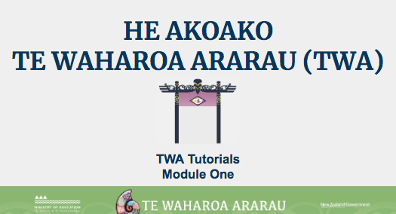 | Kei aku rangatira huri noa i Aotearoa e mātaki mai ana, tēnā tātou katoa. Nau mai ki tēnei akoako poto e pā ana ki te whakahoutanga o Te Waharoa Ararau.
Slide 2  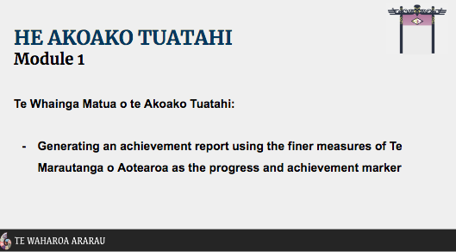 | In this tutorial, we will be demonstrating how to generate an achievement report using the finer measures of Te Marautanga O Aotearoa as the progress and achievement marker.
Slide 3  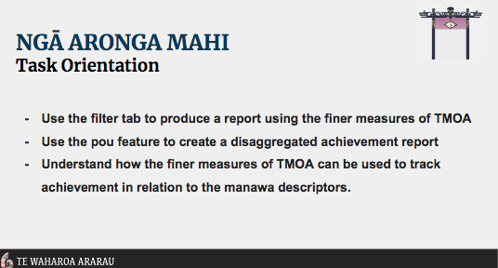 | By the end of this tutorial you will be able to:  - use the filter tab Ngā Tātaringa to produce a report using the finer measures of Te Marautanga o Aotearoa  - You will be able to Understand that the ‘finer measures’ of Te Marautanga o Aotearoa refer to the progress descriptors in Ngā Whanaketanga Rumaki Māori and the corresponding Manawa levels.  - And finally you will be able to use the pou filter to create a disaggregated achievement report  Now we’re going to look at some of the new changes to Te Waharoa Ararau.
Changes in Tab Format | Once logged into Te Waharoa Ararau, click on the Pūrongo tab to explore recent changes.  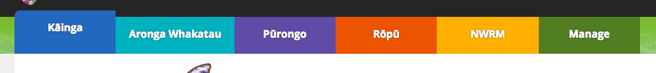
Pūrongo Tab | By using the filter tab, Ngā Tātaritanga, you can create a profile for the group or cohort you are wanting to generate a report for. Select the filter options that apply to the report you are wanting to create.  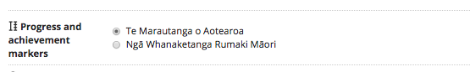  The progress and achievement marker Ngā Whanaketanga Rumaki Māori gives the user the ability to create a report using the finer measures of Te Marautanga o Aotearoa. Then click whakaae.
Summative graph for all students (or if you have selected a specific group then the graph will show this information) | Progress and achievement is displayed using Ngā Whanaketanga Rumaki Māori as the finer measure of Te Marautanga O Aotearoa taumata tahi ki te rima.  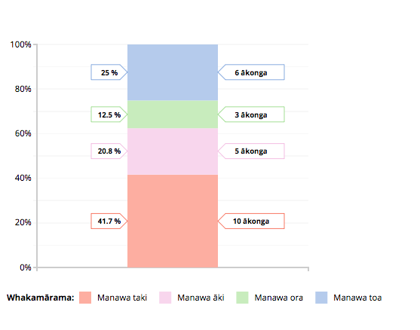
Disaggregated data by individual student | As in the previous iteration of Te Waharoa Ararau, the individual student profiles and corresponding Manawa Levels for each student are displayed below. Click on the pou drop down filter, select ngā taumata o Te Marautanga o Aotearoa. This new feature displays achievement in relation to Te Marautanga o Aotearoa alongside the manawa achievement descriptors.  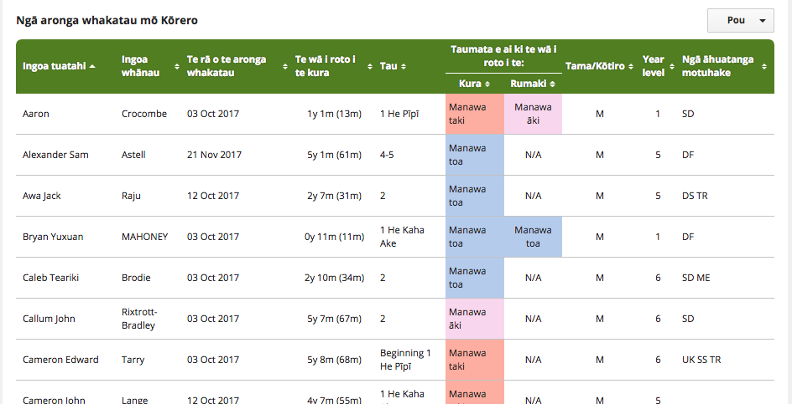
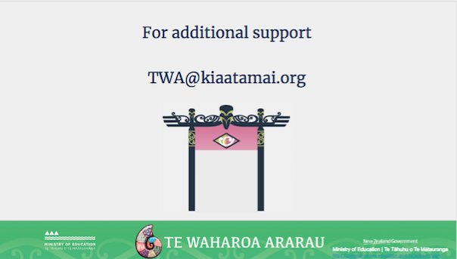 | For additional support with queries and issues as they arise, you can contact the TWA email helpline on TWA@kiaatamai.org
Slide 5  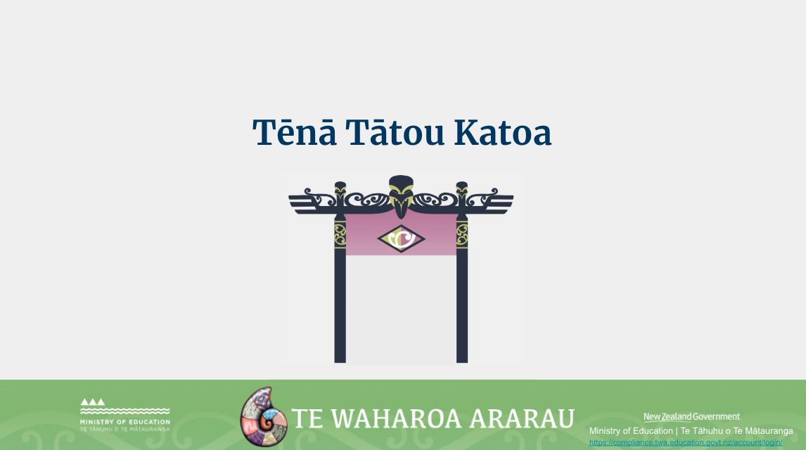 | Ko te manako ia, kua whai hua koutou i tēnei akoako poto me ngā kai o roto. Nei rā te mihi manahau ki a koutou katoa.

